NetcamCenter.nl

Product information
Manufacturer | Item number | Product number manufacturer | Date:
Axis | Q1798-LE | 01702-001 | 21-03-2024
Serial number | ACCC8EEC105E
Warranty: | 1 month money back
Suggested retail price: | 1899
Promotional price: | 949.5

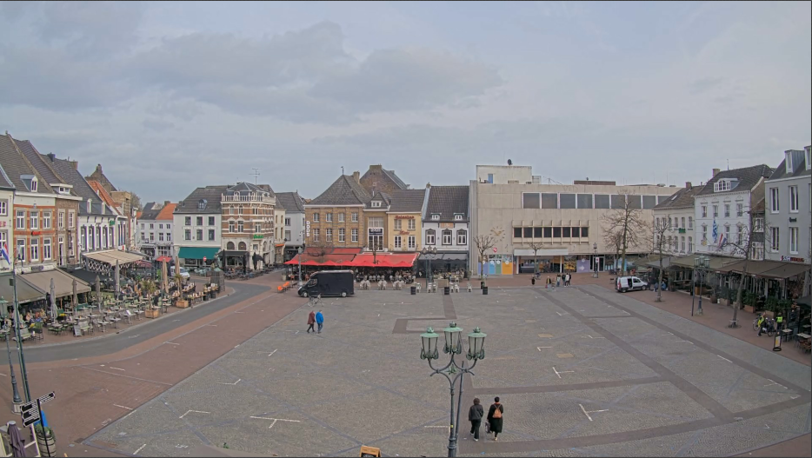 | Technical  quality | A
 |  | B
 |  | C
 |  | D
 |  |  | D | C | B | A
 |  | Optical quality
 | Rated by: |  | Joury
Picture and/or Snapshot

Product condition:
This product is both technically and optically fine. Housing has some signs of use
Accessories information:
Everything included except Manual

Packaging information:
No original packaging available

*Warranty: Exclusive right to a refund if the product is returned including all accessories and undamaged packaging. No right to a replacement product.

